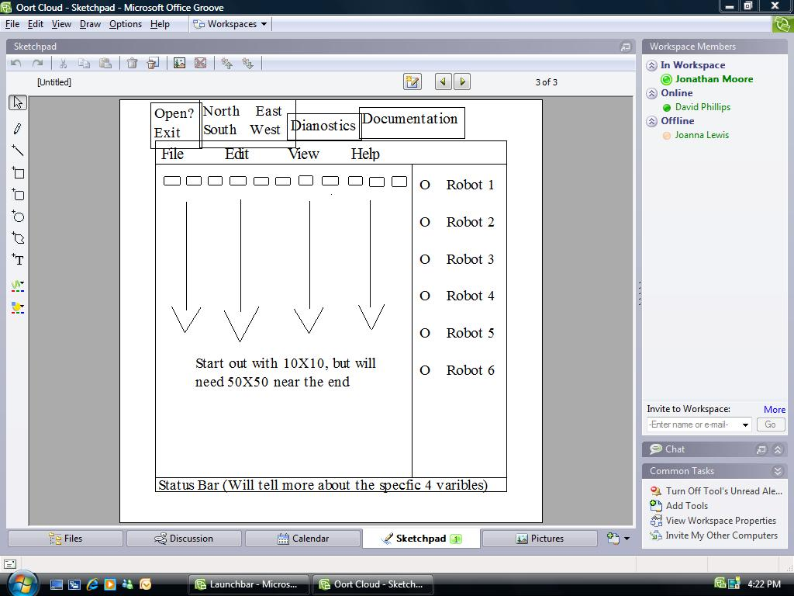

This is a sketch of the prototype when we first came up with the concept.

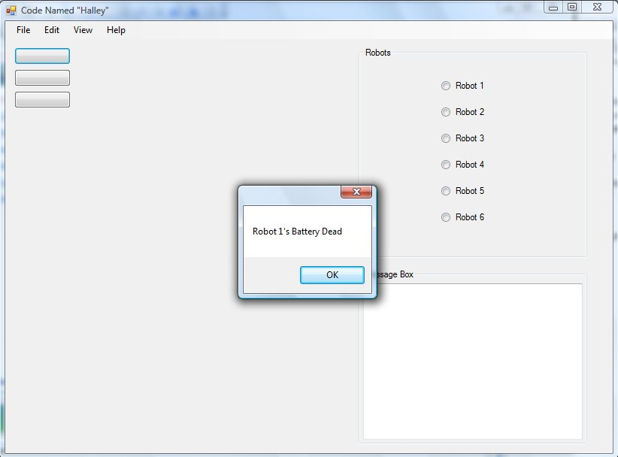

This screenshot is displaying the Robot’s 1 Battery Dead Message Box

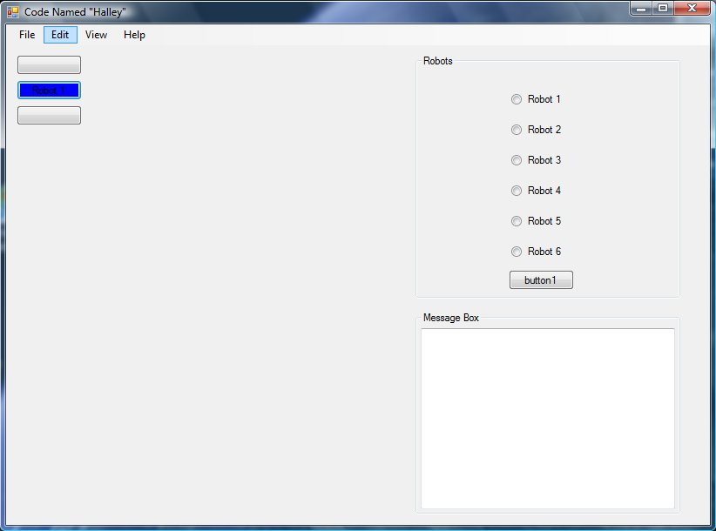

The shot is showing the movement of robot 1 along the button controls using the arrow keys.

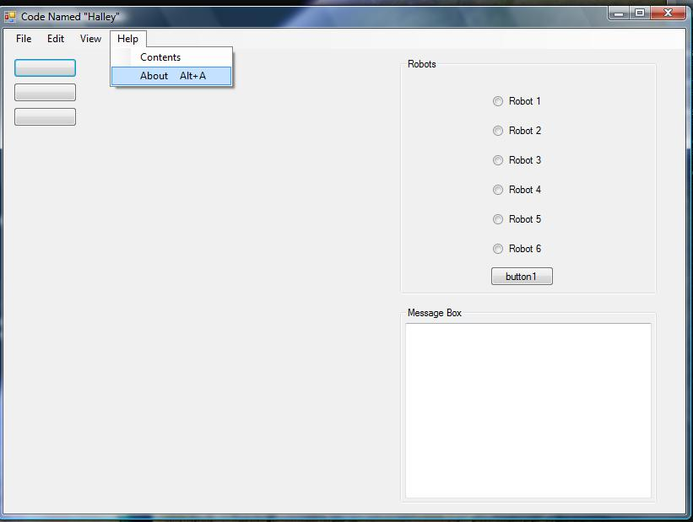

The help menu is displaying the about menu option with shortcut keys.

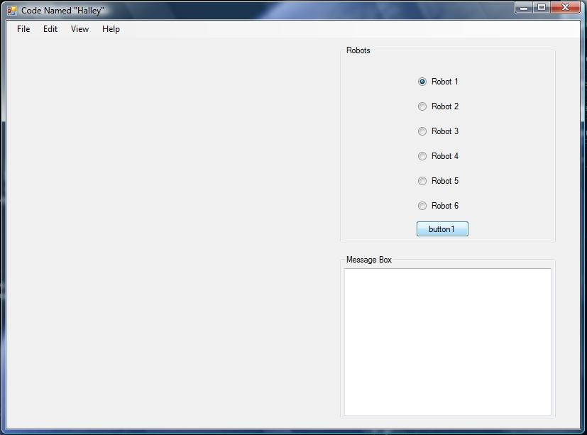

This shot is displaying when Robot 1 ‘s Radio Button is selected and button1 is pressed Robot 1’s Buttons are hidden and in future releases Robot 2’s buttons will be shown. Also in future releases are messages will be routed to the Multiline Text Box “MessageBox” as seen above. Such as battery life and other diagnostics.